Date:31/10/2023

Project ID:proj_223333_Team_4

Project title: Traffic management

Phase 5

**Traffic management IOD objective:**

Traffic management Internet of Things (IoT) objectives can vary depending on the specific goals of a smart traffic management system, but here are some common objectives:

1.Trafficptimization:

IoT can help optimize traffic flow by collecting real-time data from sensors and cameras to adjust signal timing and route traffic efficiently.

2.Congestion Reduction:

congestion and traffic jams through data-driven decision-making, rerouting, and dynamic management of traffic.

3.Safety Improvement:

Enhance road safety by detecting accidents or hazardous conditions and alerting authorities and drivers promptly.

4.Emissions Reduction:

Minimize fuel consumption and air pollution by reducing idling time and congestion, as well as promoting eco-friendly transportation options.

5.Real-timeitoring:

Continuously monitor traffic conditions to provide up-to-date information to commuters through apps or variable message signs.

6.Parking Management:

Efficiently manage parking spaces by guiding drivers to available spots, reducing circling and emissions.

7.Emergency Response:

Facilitate quicker emergency response by prioritizing traffic routes and clearing the way for first responders.

8.Data Analysis:

Gather and analyze traffic data for long-term planning, identifying trends, and making infrastructure improvements.

9.Integration with Public Transport:

Integrate traffic management with public transportation systems to encourage multimodal commuting and improve overall mobility.

10.Energy Efficiency:

Minimize energy consumption of traffic infrastructure through smart lighting and signaling.

11.Cost Savings:

Reduce operational costs through more efficient use of resources and reduced maintenance needs.

12.Resilience and Disaster Management:

Implement systems that can adapt to and manage traffic during emergencies or natural disasters.

13.User Experience:

Enhance the overall experience of commuters by providing real-time traffic information, alternative route suggestions, and seamless transportation options.

14.Privacy and Security:

Ensure the security of data and user privacy in the collection and dissemination of traffic information.

**IOT device setup in traffic management :**

Setting up IoT devices for traffic management involves deploying sensors, cameras, and communication technology to monitor and manage traffic flow efficiently. Here's a high-level overview of the process:

1.Identify Objectives:

Determine the specific goals of your traffic management system, such as reducing congestion, improving safety, or optimizing traffic signal timings.

**IoT Devices**:

Traffic Sensors:

Install various sensors like inductive loops, ultrasonic sensors, or radar sensors to detect vehicles and measure traffic flow.

Cameras:

Use cameras for video surveillance, license plate recognition, and traffic analysis.

Environmental Sensors:

Deploy weather and air quality sensors to account for weather conditions and pollution in traffic management decisions.

Connectivity:

Establish a robust communication network to connect IoT devices. This could be through cellular, Wi-Fi, or low-power wide-area networks (LPWAN).

**Data Collection:**

IoT devices collect data on vehicle counts, speeds, congestion, and environmental conditions.

Data may be transmitted in real-time or periodically to a central server or cloud platform.

**Data Processing and Analysis:**

Implement analytics and machine learning algorithms to process the collected data.

Use this data to make real-time traffic management decisions.

**Traffic Control:**

Adjust traffic signal timings, control variable message signs, or manage toll booth operations based on the data and analysis.

**User Interface**:

Develop a user interface for traffic operators to monitor and control the system. This can be a web-based dashboard or a mobile app.

**Integration with Other Systems:**

Integrate your traffic management system with other transportation systems like public transit, emergency services, and urban planning.

**Maintenance and Security:**

Regularly maintain IoT devices and ensure they are secure to prevent unauthorized access.

**Feedback and Optimization:**

Continuously gather feedback and data to optimize traffic management strategies and improve the system's performance.

**Scalability:**

Design the system to be scalable, as traffic patterns and the number of connected devices may change over time.

**Regulatory Compliance:**

Ensure that your system complies with local regulations and privacy laws, especially when using video cameras.

**Public Awareness:**

Educate the public about the benefits of the system and how it can improve traffic conditions and safety.

Traffic management with IoT devices can significantly enhance urban mobility and reduce congestion, leading to improved safety and quality of life for residential

**IOT platform development in traffic management :**

Developing an IoT platform for traffic management involves various components and steps:

Sensors and Devices:

Deploy sensors and devices (e.g., cameras, traffic lights, vehicle detectors) at key locations to collect real-time data.

Data Collection:

Gather data from these sensors, including vehicle counts, traffic flow, and environmental conditions.

Connectivity:

Ensure reliable connectivity through protocols like Wi-Fi, cellular, or LoRaWAN to transmit data to a central platform.

Cloud Infrastructure:

Set up cloud-based infrastructure to store and process data. Services like AWS, Azure, or Google Cloud can be used.

Data Processing:

Analyze incoming data to monitor traffic conditions, detect congestion, and identify trends or anomalies.

Data Visualization:

Create dashboards and reports to present real-time and historical traffic data to users and operators.

Traffic Control:

Implement adaptive traffic control systems that can adjust signal timings based on real-time traffic conditions.

Machine Learning:

Use ML algorithms to predict traffic patterns, optimize signal timing, and improve traffic flow.

User Interface:

Develop user-friendly interfaces for traffic managers, city officials, and even the public to access traffic information.

Security:

Ensure data security and privacy, as traffic data can be sensitive. Use encryption, access controls, and secure device management.

Scalability:

Design the platform to scale as traffic management needs grow.

Maintenance and Updates:

Regularly maintain and update the system to ensure its efficiency and security.

Integration:

Integrate with other city systems like public transportation, emergency services, and smart city initiatives

**IOT code implementation in traffic management :**

Implementing IoT (Internet of Things) in traffic management involves using sensors, cameras, and data analytics to monitor and control traffic flow. Here’s a high-level overview of how you can implement IoT in traffic management:

**Sensors and Data Collection:**

Install various sensors (e.g., traffic flow sensors, vehicle presence detectors, and environmental sensors) at key locations on roads and intersections.

These sensors collect data on traffic volume, vehicle speed, and environmental conditions.

**Data Transmission:**

Use wireless communication protocols like Wi-Fi, cellular, or LoRa to transmit the collected data to a central control system.

**Central Control System:**

Set up a central server or cloud-based platform to receive, store, and process the data.

Implement a database to store historical and real-time traffic data.

**Data Analysis and Traffic Management:**

Employ data analytics and machine learning algorithms to process the data and extract useful insights.

Use this data to predict traffic congestion, accidents, or roadblocks.

Implement traffic management algorithms to optimize traffic signals and control systems.

Dynamic traffic signal control can be used to adapt to changing traffic conditions.

**Traffic Signal Control:**

Adjust traffic signals in real-time based on the data received.

Prioritize emergency vehicles, public transport, or high-traffic routes during peak hours.

**Communication with Vehicles:**

Implement Vehicle-to-Infrastructure (V2I) and Vehicle-to-Vehicle (V2V) communication systems to send alerts to drivers.

Provide real-time traffic information to drivers through mobile apps, in-car systems, or road signs.

**Public Information:**

Share real-time traffic information with the public through websites, mobile apps, and electronic road signs.

**Safety and Surveillance:**

Use cameras for surveillance and monitoring of traffic conditions.

Implement automated license plate recognition (ALPR) systems for law enforcement and security.

**Scalability and Redundancy:**

Ensure the system is scalable to accommodate growth in the number of sensors and users.

Implement redundancy to ensure system availability in case of failures.

**Privacy and Security:**

Implement robust security measures to protect the data and communication systems.

Ensure compliance with privacy regulations, as traffic data can be sensitive.

**Maintenance and Updates:**

Regularly maintain and update the IoT infrastructure to keep it efficient and secure.

**Feedback and Improvement:**

Collect feedback from users and authorities to continuously improve the system.

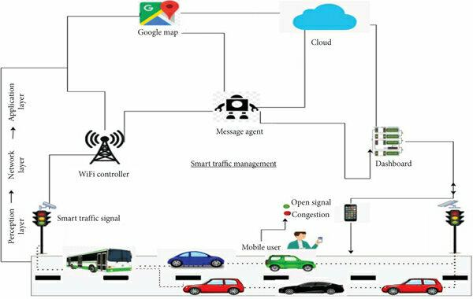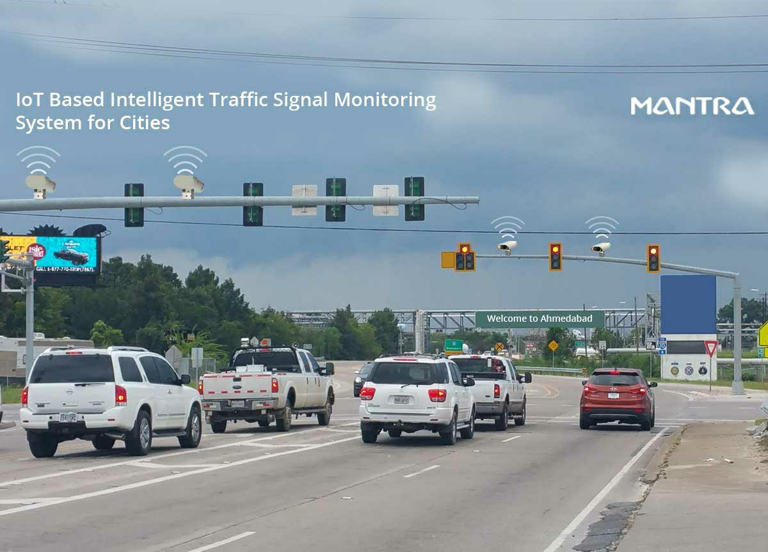

**IOT traffic management:**

In traffic management, IoT (Internet of Things) plays a crucial role by connecting various devices and sensors to gather real-time data and improve traffic flow and safety. Here's how IoT is used in traffic management:

**Traffic Monitoring:**

IoT sensors placed on roads, traffic lights, and in vehicles collect data on traffic flow, congestion, and vehicle speed. This information is then transmitted to a central control system.

**Smart Traffic Lights:**

IoT-enabled traffic lights can adjust signal timings in real-time based on traffic conditions, reducing congestion and optimizing traffic flow.

**Vehicle Detection:**

IoT sensors can detect the presence of vehicles at intersections and provide data to control systems to manage traffic signal changes effectively.

**Parking Management:**

Smart parking solutions use IoT to guide drivers to available parking spaces, reducing the time spent searching for parking and alleviating congestion.

**Emergency Response:**

IoT can be used to prioritize traffic signals for emergency vehicles, ensuring faster response times during emergencies.

**Dynamic Message Signs:**

Electronic signs that provide real-time traffic information to drivers, such as road closures, accidents, and alternative routes, are powered by IoT data.

**Data Analytics:**

IoT data is analyzed to identify traffic patterns and optimize traffic management strategies, such as adjusting signal timings and rerouting traffic.

**Environmental Impact**:

IoT can help reduce emissions by optimizing traffic flow, reducing congestion, and promoting eco-friendly transportation options.

**Public Transportation:**

IoT can be used to track public transit vehicles, offer real-time schedules, and improve the overall efficiency of public transportation systems.

**Pedestrian Safety:**

IoT sensors can be used to detect pedestrians at crosswalks and improve safety by adjusting traffic signals to allow safe crossings.